CIRCUIT CONNECTIONS, COMPONENTS & WORKING
An Integrated Smart Helmet System Using IoT for Enhanced Rider Safety

1. System Block Diagram
The block diagram below shows how all inputs (battery, MQ-3 alcohol sensor, limit switch, MPU6050, GPS module) and outputs (buzzer, relay module, Telegram bot, Wi-Fi module) connect through the central ESP32 microcontroller.
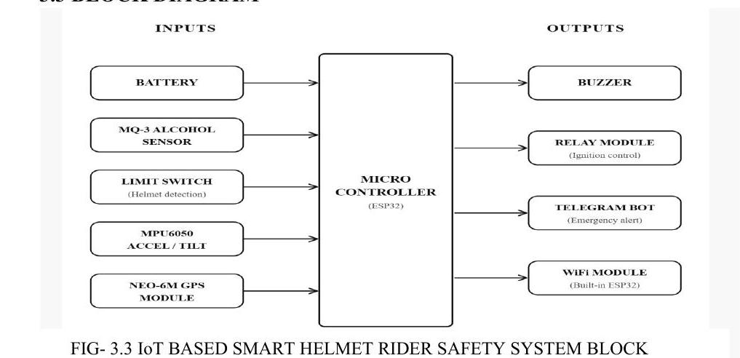
FIG. 3.3 IoT Based Smart Helmet Rider Safety System — Block Representation

2. Circuit / Schematic Diagram
The schematic diagram shows the exact GPIO pin connections between the ESP32 and each sensor/output module, along with the power distribution from the Li-ion battery through the voltage regulator.
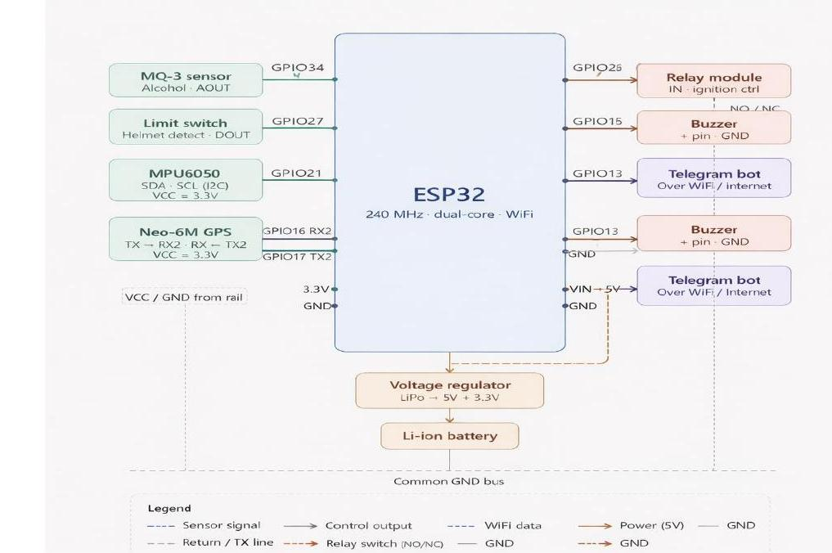
FIG. 3.4 IoT Based Smart Helmet Rider Safety System — Schematic Diagram

Pin Connection Summary
Component | ESP32 Pin | Interface | Function
MQ-3 Alcohol Sensor | GPIO34 (ADC) | Analog | Alcohol level (AOUT)
Limit Switch | GPIO27 | Digital In | Helmet detect (DOUT)
MPU6050 | GPIO21 / GPIO22 | I2C (SDA/SCL) | Motion / accident detection
NEO-6M GPS | GPIO16 (RX2) / GPIO17 (TX2) | UART | Live location tracking
Relay Module | GPIO26 | Digital Out | Ignition control (NO/NC)
Buzzer | GPIO15 | Digital Out | Local audible alert
Telegram Bot | Built-in Wi-Fi | Wi-Fi / Internet | Emergency alert transmission
Battery -> Regulator | 3.3V / VIN | Power | 5V -> 3.3V regulated supply

3. Actual Wired Prototype (Working Circuit Connection)
The photograph below shows the real, physically wired prototype corresponding to the schematic above — the ESP32, MQ-3 sensor, MPU6050, relay module, GPS module, and battery pack are connected exactly as per the circuit design and were used for all functional testing.
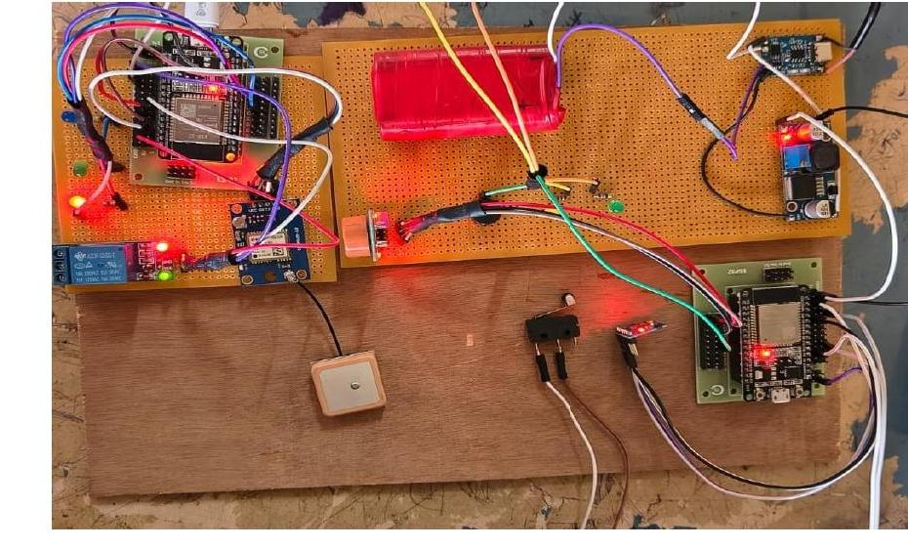
FIG. 3.5 Working Model of the Project — Actual Wired Connections

4. Hardware Components — Photos and Working
Each of the following components is shown with its photo, the GPIO pin(s) it connects to on the ESP32 (see the pin-connection table above), and a short description of its role and working in the overall circuit.
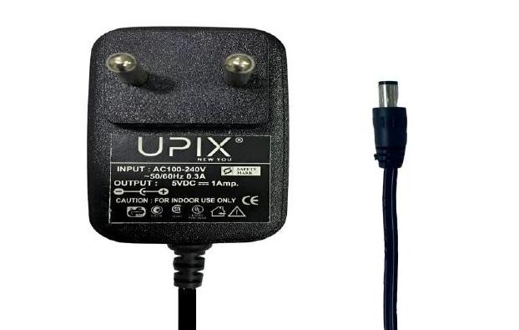 | 4.1 Power Supply — DC Power Adapter  A standard 5V DC adapter (AC-to-DC) supplies stable power to the ESP32 and associated components, either through the USB port or the VIN pin, suitable for testing, development, and lab demonstrations.

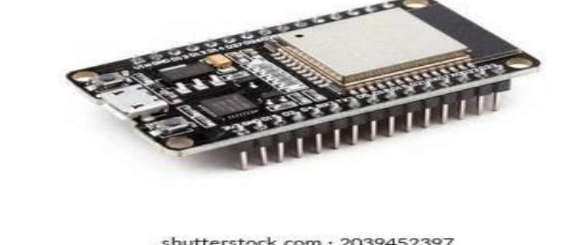 | 4.2 ESP32 Development Board  The core microcontroller of the system. Combines processing, Wi-Fi, and Bluetooth connectivity, coordinating all sensors and output modules (relay, buzzer, Telegram bot) via its GPIO pins.

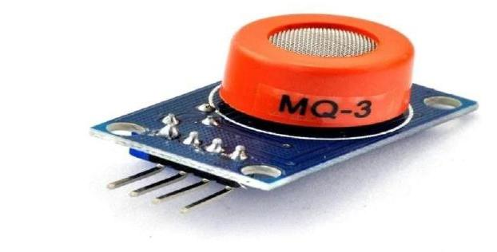 | 4.3 MQ-3 Alcohol Sensor  Connected to an analog GPIO (ADC) pin on the ESP32. Detects alcohol vapor concentration in the rider's breath and outputs an analog voltage proportional to alcohol level, compared against a threshold in firmware.

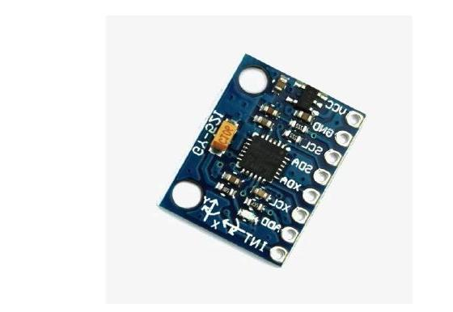 | 4.4 MPU6050 (Accelerometer + Gyroscope)  Connected via I2C (SDA -> GPIO21, SCL -> GPIO22). Provides 3-axis acceleration and rotation data used to detect sudden impacts, falls, or abnormal tilting that indicate an accident.

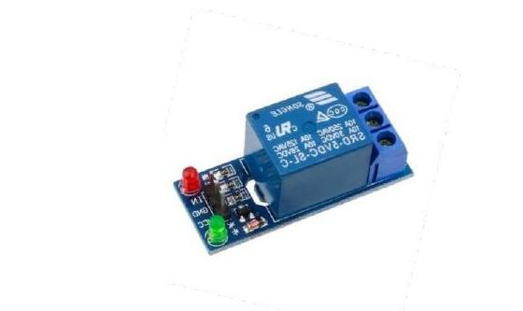 | 4.5 Relay Module  Acts as an electrically controlled switch connected to a digital output GPIO of the ESP32. Controls the bike's ignition circuit — engaging only when the helmet is worn and no alcohol is detected.

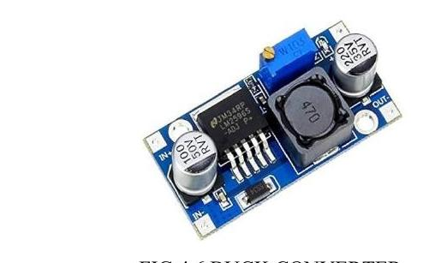 | 4.6 Buck Converter  A DC-DC step-down converter placed between the 18650 Li-ion battery and the ESP32/sensor rail, regulating the higher battery voltage down to a safe, stable 5V/3.3V supply.

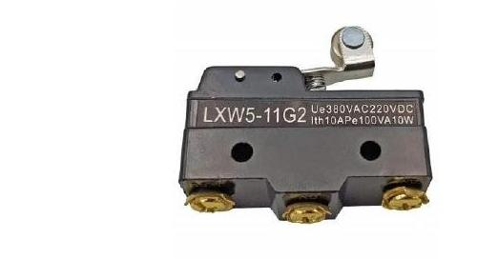 | 4.7 Limit Switch  Connected to a digital input GPIO (GPIO27) inside the helmet. Mechanically pressed when the helmet is worn, completing the circuit and signalling helmet-detection status to the ESP32.

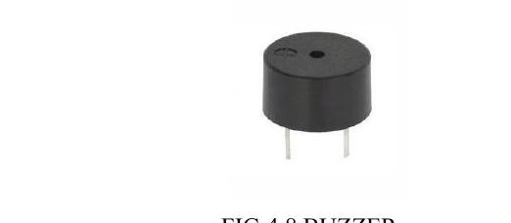 | 4.8 Buzzer  Connected to a digital output GPIO (GPIO15). Provides an immediate audible alert for conditions such as helmet not worn, alcohol detected, or accident detected.

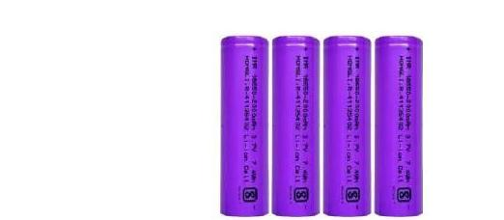 | 4.9 18650 Lithium-ion Battery  The rechargeable power source for the entire helmet circuit, feeding the buck converter / voltage regulator that powers the ESP32 and all connected sensors and modules.

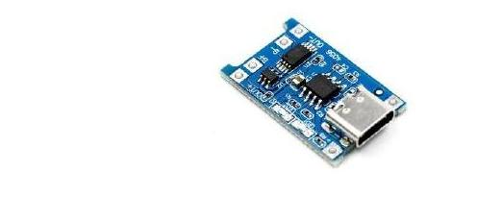 | 4.10 TP4056 Charging Module  Manages safe charging of the 18650 battery via USB, with built-in overcharge and over-discharge protection to preserve battery health and safety.

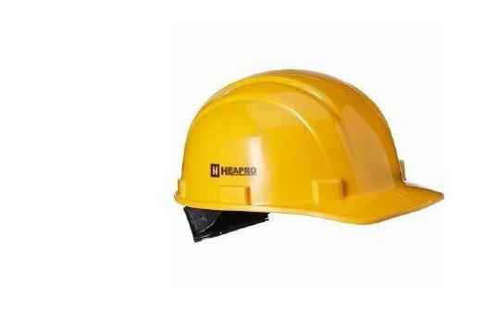 | 4.11 Helmet (Physical Platform)  Houses and integrates all electronic components — ESP32, sensors, relay, buzzer, and battery — providing both physical head protection and the mounting platform for the smart system.

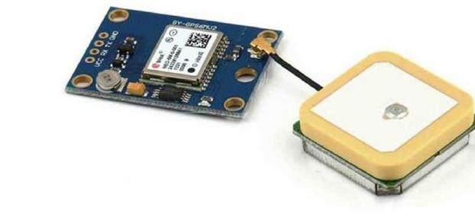 | 4.12 NEO-6M GPS Module  Connected via UART (TX -> GPIO16/RX2, RX -> GPIO17/TX2). Continuously receives satellite signals to compute the rider's live latitude and longitude, sent to the ESP32 for transmission during emergencies.

5. ESP32 Pin Configuration Diagram
The full ESP32 pinout, showing every GPIO's default function (ADC/DAC channel, I2C, SPI, UART, PWM), used as the reference for all wiring shown in the schematic diagram above.
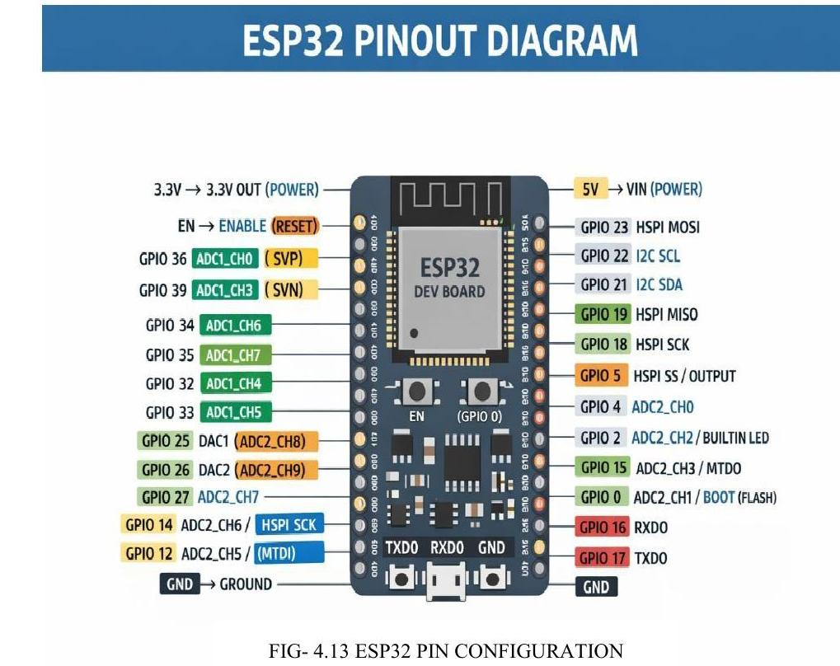
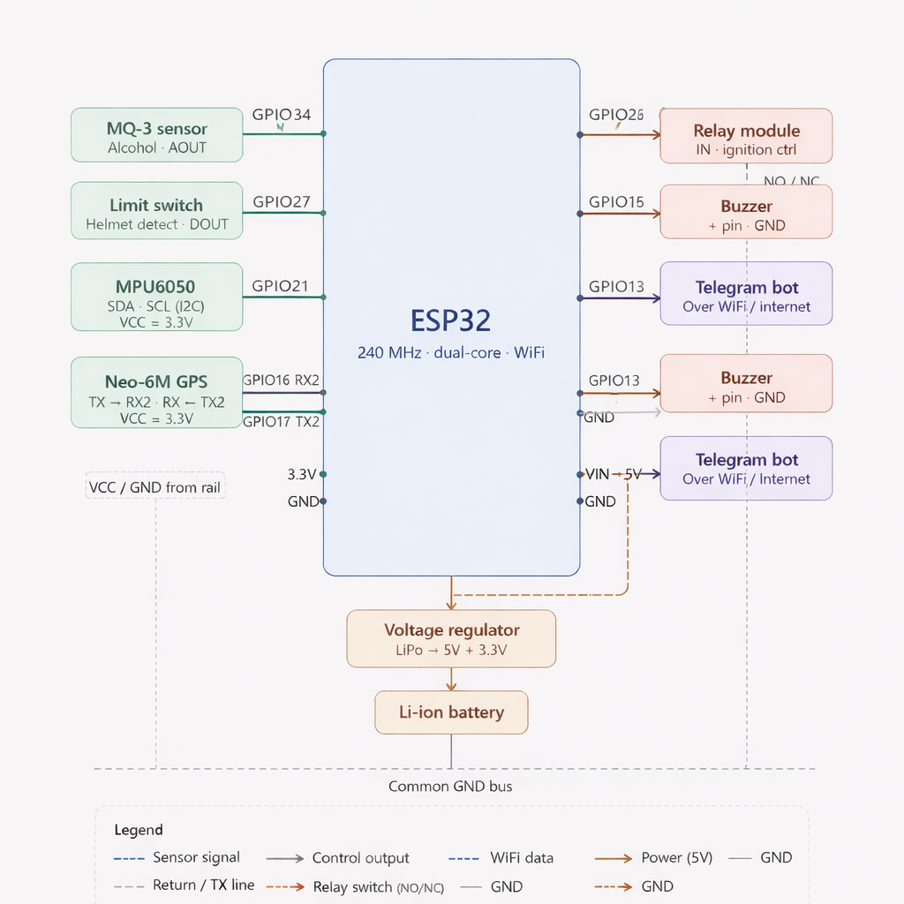
ESP32 Pin Configuration
IoT BASED SMART HELMET RIDER SAFETY SYSTEM
SCHEMATIC DIAGRAM

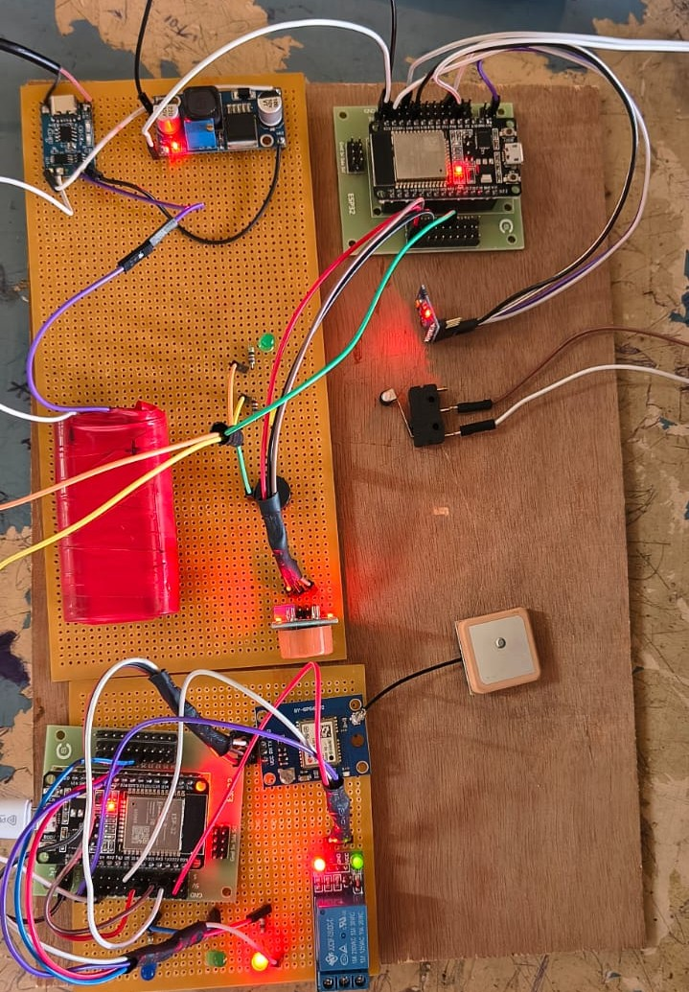
FIG.3.5 WORKING MODEL OF PROJECT

